Python notes and trouble shooting
Downloading pandas, Openpyxml
Checking for python version – Open cmd prompt and type python -V (Note that python -Version didn’t work)
Installing pandas – pip install pandas.
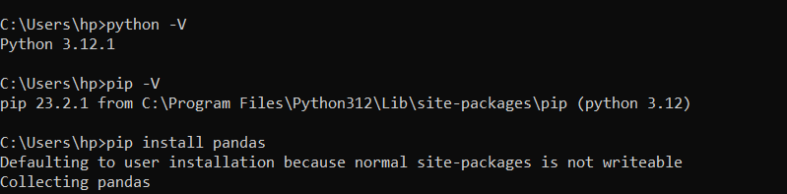

Next – Write script in notepad and save with a .py extension.
Navigate path in cmd to directory with the script to be run.
Run script – python “filename”.py
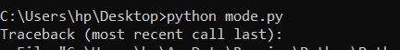

Writing script
- For just 1 run

import pandas as pd
import xml.etree.ElementTree as ET
import os

# Define the scenario number
scenario = 1

# Define the path to the Excel file
excel_path = r'D:\GCAM\Scenario_Input_cost\input_cost.xlsx'

# Read the Excel file
df = pd.read_excel(excel_path)

# Print available column names
print("Available columns in the Excel file:", df.columns)

# Check if 'Scenario' column exists
if 'Scenario' not in df.columns:
raise ValueError("Column 'Scenario' not found in the Excel file.")

input_cost = df.loc[df['Scenario'] == scenario, 'Inputcost'].iloc[0]

# Define the path to the template XML file and the path for the new XML file
template_xml_path = r'D:\GCAM\Scenario_Input_cost\en_fert_template.xml'
new_xml_file_path = r'D:\GCAM\XML\en_fert_{}.xml'.format(scenario)

# Read and modify the XML file
tree = ET.parse(template_xml_path)
root = tree.getroot()

# Assuming 'FEWtures' is a text in an element, find and replace it
# This part may need adjustment depending on the XML structure
for elem in root.iter():
if elem.text == "FEWtures":
elem.text = str(input_cost)

# Save the modified XML file
tree.write(new_xml_file_path)

print(f'File saved as: {new_xml_file_path}')

- For all 1024 runs

#import pandas as pd ( Had to first download pandas using cmd prompt)
import xml.etree.ElementTree as ET
import os

# Define the path to the Excel file
excel_path = r'D:\GCAM\Scenario_Input_cost\input_cost.xlsx'

# Read the Excel file
df = pd.read_excel(excel_path)

# Check if 'Scenario' column exists
if 'Scenario' not in df.columns:
raise ValueError("Column 'Scenario' not found in the Excel file.")

# Define the path to the template XML file
template_xml_path = r'D:\GCAM\Scenario_Input_cost\en_fert_template.xml'

# Output directory for new XML files
output_dir = r'D:\GCAM\XML_Files'
if not os.path.exists(output_dir):
os.makedirs(output_dir)

# Process each scenario
for scenario in range(1, 1025):
# Lookup input cost for the scenario number
if scenario in df['Scenario'].values:
input_cost = df.loc[df['Scenario'] == scenario, 'Inputcost'].iloc[0]
else:
print(f"Scenario number {scenario} not found in the Excel file.")
continue

# Define the path for the new XML file
new_xml_file_path = os.path.join(output_dir, f'en_fert_{scenario}.xml')

# Copy and modify the XML file
tree = ET.parse(template_xml_path)
root = tree.getroot()

# Assuming 'FEWtures' is a text in an element
for elem in root.iter():
if elem.text == "FEWtures":
elem.text = str(input_cost)

# Save the modified XML file
tree.write(new_xml_file_path)

print(f'File en_fert_{scenario}.xml created with input cost: {input_cost}')

